The G20 Preparatory Process

Ten Options to Improve G20 Effectiveness

Barry Carin\* and Ye Yu\*\*

“Since the early 1990s, the need for effective multicountry collaboration has soared, but at the same time multilateral talks have inevitably failed; deadlines have been missed; financial commitments and promises have not been honored; execution has stalled; and international collective action has fallen far short of what was offered and, more importantly, needed.”[[1]](#footnote-0)

Introduction

Format is substance. The preparatory process forG20 Leaders Meetings will determine future effectiveness. The G20 is overburdened. Leaders meetings are faced with unrealistic demands and excessive expectations. The G20 is an informal organization- it has no constitution, no bylaws, no secretariat, and no compliance mechanisms. It has no formal provisions for institutional memory or continuity. Yet every country and every organization want to participate in its agenda-setting and deliberations. The informal network is growing too fragmented and cumbersome, with so many meetings, outreaches, and consultations going on. There is also an increasing demand for an effective accountability mechanism to provide teeth for the informal process.

Streamlining operations are needed to enhance the effectiveness of this group process. China is going to host the G20 in 2016. It may shun leadership, recalling the proverb that “When you are on the top of the mountain, you are unable to stand up to the cold”. However, China should take advantage of its presidency in 2016 to initiate a series of reforms of the preparatory process to ensure effectiveness of the G20.Inspired by ancient Chinese wisdom, the reforms should enhance the following values and merits: leadership and ownership, simplicity, and softness. This paper reviews ten approaches to modernize the G20 preparatory process.

|  |  |
| --- | --- |
| **Values** | **Approaches** |
| Leadership and ownership | 1.Troika becomes Quintet with US & China as permanent members |
| 2. “Non- Secretariat” |
| 3. Select G2 0 Presidencies for the next 5 years |
| Simplicity | 4. Merge Sherpa & Finance Deputy tracks |
| 5. Consolidate Outreach into single Davos-type event |
| 6. Disinvite International Organizations |
| 7. Manage Agenda Creep |
| Softness | 8.Deemphasize Accountability |
| 9. Report on G20 members’ successes |
| 10. Invite reports for future meetings |

**Leadership and ownership**

***“All streams flow to the sea because it is lower than they are.” Lao Tzu***

1. **Transform Troika into Quintet with US & China as permanent members**

The preparatory process for summits is a challenging task and an enormous burden. The increased number of participants in G20 summits complicates the logistics of a process that was designed for a meeting of eight countries, not today’s twenty plus five additional guests. The Presidency is responsible for coordinating ever more Ministers, officials, working groups and sources of information. The current process places too much responsibility on the G20 presidency.

A permanent Secretariat is not the answer. The preparatory process must be driven by capitals. The puzzle is how to create the requisite leadership and spread the administrative burden to provide the requisite institutional memory and follow up of Leaders’ instructions and commitments. Adding China and the US to the Troika and making the new “Quintet” jointly responsible for all agenda- setting decisions would expedite G20 decision making. **It is unrealistic to expect progress on preparing for decisions on complex, contentious issues without the full engagement of both China and the United States. The Quintet with US and China should resemble** the leadership group or executive committee called the “Bureau” in each OECD Committee. A small number of delegates are designated annually to serve. The Bureau is responsible for preparation of the Committee’s work. The Bureau meetings are open to all committee members who may attend and participate if they wish[[2]](#footnote-1).

Future G20 agendas should be prepared by a G20 “Bureau”, an Executive Committee of Leaders’ representatives. The Chair of this “G20 Bureau” would be the Sherpa of the host country. Presidencies after 2016 would follow the G20 “bucket system”[[3]](#footnote-2). Since the success of any proposal will require the support of the US and China, after 2016 the other members of the G20 Bureau would be the China and the US, plus the other two Troika members.

G20 Sherpa and Working Group meetings can have upwards of one hundred people in the room.[[4]](#footnote-3) An efficient steering or executive committee is essential. A “Quintet Bureau” is also a way to share the heavy burden of seeking substantive input from G20 non-members and civil society who insist on substantive consultation. The onerous travel requirements of communicating the outcomes from the G20 proceedings can be apportioned among Quintet members.

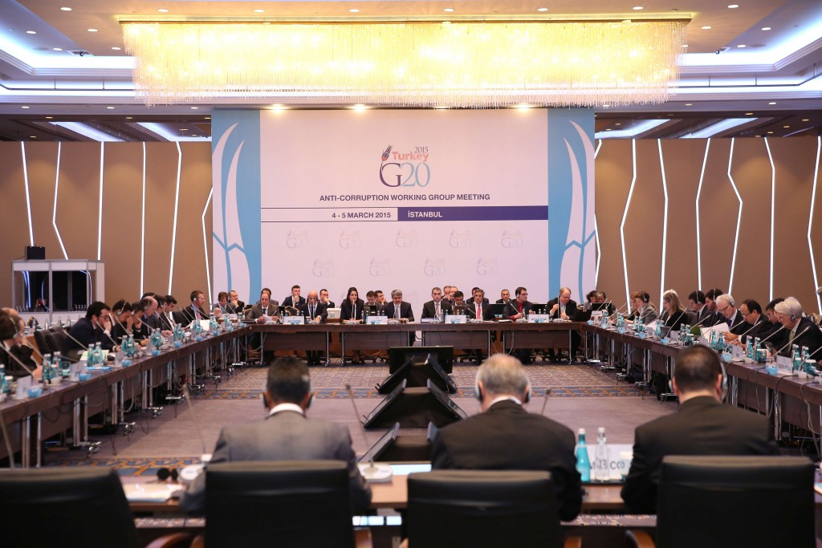

**2. Establish a “NON-Secretariat”**

President Sarkozy noted that "The G20 decided it would be the ‘main global forum’ for economic and financial issues. But it must still give itself the means to work more effectively. Shouldn’t we create a G20 Secretariat to continuously monitor the implementation of decisions and deal with issues in conjunction with all pertinent international organizations? "[[5]](#footnote-4)

The G20 would be more effective if it had a mechanism to ensure institutional memory, effective information collection, outreach, and policy implementation while avoiding bureaucratization. Without a permanent secretariat, an unenthusiastic G20 host could sink the whole enterprise.  In a permanent structure, each G20 member country would probably eventually have a diplomatic mission at the venue of the secretariat. A permanent location could build an effective peer-learning and peer-evaluation mechanism. As the G20 issue space expands from macro-financial policy to a growth-oriented development agenda, climate change, and so on, it may become increasingly important to have in place peer mechanisms within the G20 based on rigorous analytical standards.

But a conventional permanent secretariat with one Secretary General and its own staff is out of the question. There would be battles over choice of the Secretariat’s location[[6]](#footnote-5) and the Secretary General. We must avoid bureaucratization, agenda-setting by unaccountable technocrats, loss of Leaders’ control and with it the loss of Leaders’ commitment. Then the answer is a “Taoist” Non secretariat, with staggered secondments from Quintet countries for 3 years. Sherpas and Finance Deputies from the Quintet countries would be de facto co-Secretaries-General to ensure direct accountability to the host countries. With Sherpas running the show, there is no danger of lifelong bureaucrats capturing the process. “Staff” would be provided by Quintet G20 teams sending officials to the presidency country for several weeks to work together three or four times a year. In other words China would invite senior officials from the US, Turkey and Germany to Beijing for a few stints of several weeks to shape and hammer out options for the Leaders.

**3. Select G20 Presidencies for the next 5 years**

Currently, the G20 presidency is determined two years in advance, with a rotation across five groups, a process inherited from G20 Finance Ministers.

|  |  |  |  |  |
| --- | --- | --- | --- | --- |
| **Group 1** | **Group 2** | **Group 3** | **Group 4** | **Group 5** |
| Australia | India | Argentina | France | China |
| Canada | Russia | Brazil | Italy | Indonesia |
| Saudi Arabia | South Africa | Mexico | Germany | Japan |
| USA | Turkey |  | United Kingdom | South Korea |

In November 2014, it was announced that China will assume the responsibility in 2016. In November 2015, the decision will be made on the 2017 presidency.

One way to improve the climate in G20 proceedings is to instill a sense of ownership in as many countries as possible. One easy way to do this is to designate the G20 presidencies for the following five years. This simple act will provide incentives to five other G20 members to pay more attention to ensure the success of the G20, since they know they will inherit the consequences.

**Simplicity**

***“I have just three things to teach: simplicity, patience, compassion.” Lao Tzu***

**4. Merge Sherpa & Finance Deputy tracks**

China should keep it simple and consolidate the two-track Sherpa and Finance Deputy processes, introduced in 2012 by the Mexican G20 presidency. In the two track approach, issues where finance is critical, like development, anti-corruption and employment, are assigned to the Sherpa track – a waste of time, if not an exercise in futility. The Development Working Group has no direct connection to the guardians of fiscal instruments. The Anti-corruption Working Group does not have a direct line to anti –money laundering authorities. The preparatory process structure should be simplified. All working groups should include experts from the appropriate ministries. All working groups should report to the Leaders Personal Representative – drawn from whatever ministry or agency each Leader prefers.

A sketch of the G20’s two tracks[[7]](#footnote-6)

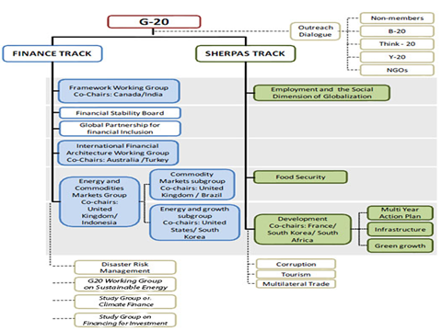

**5. Consolidate Outreach into a single Davos-type event**

The G20 Presidency is confronted by a long list of demands for a substantive hearing. A great deal of time is expended in travel and outreach sessions by key staff responsible for the G20 preparatory process. Many of the events are pro forma (e.g. Turkey’s Caribbean Region Dialogue), with Sherpas and finance deputies learning nothing new. Time would be better spent in preparing practical options and recommendations for Leaders

China should streamline the onerous outreach process by inviting all engagement groups (B20, L20, T20, Y20, and W20), and all non- member countries to a well- advertised 3 day Davos type event to communicate their priorities to the G20 Sherpas and finance deputies. A consolidated event will temper the demands of all the petitioners, when they clearly understand the extensive list of competing priorities of other groups

The presidency could provide dedicated one hour audiences to each advocacy group and to non-member countries. This approach, listening respectfully, will allow interveners and advocacy groups to save face and to report to their constituencies that they delivered their messages. It will also save countless hours of travel to receive briefs.

**6. Disinvite International Organizations**

Perhaps the most egregious error made by previous G20 officials has been to invite the representatives of international organizations to routinely participate as equals in the preparatory process. Even engagement groups demand access and privileged status; one example is the Business 20 appointing a “B20 Sherpa”. Effectiveness is compromised when there are too many people at the table. The G20 process is constrained by a limited amount of time available for consultation, negotiation and problem solving.

Given the limited number and duration of meetings, the invitations to Spain, other guests and international organizations make the G20 unworkable. International organizations are the servants of sovereign states. They should provide briefings and support when requested. The prospects of finding common ground beyond lowest common denominator positions are compromised if officials of international organizations are an integral part of the process.

**7**. **Manage Agenda Creep**

The Chinese G20 presidency should correct an error made by the French after the 2009 London Summit. The G20 ignored Il SaKong’s advice “not to dilute the focus of the Summit by adding other heavyweight issues such as climate change”[[8]](#footnote-7).

Recent G20 presidencies have diluted the focus by adding agenda items. Korea added development; Mexico green growth; Australia infrastructure; Turkey has announced priorities of inclusive development, reinvigoration of the multilateral trading system, employment, small and medium enterprises, investment, energy, climate change, as well as inherited agenda items, such as tax and growth strategies.Turkish Prime Minister Davutoglu's pronounced “on most issues we act as the heads of nation states, but on climate change we should act as the ministers of home affairs of humanity in dealing with the biggest challenge to all of humanity'”, suggesting that issues such as pandemics and health emergencies had a natural place in G20 discussions.[[9]](#footnote-8)

The Schedule of events in the Turkish calendar reveals the extent of dilution. The calendar includes G20 Working Group meetings (Framework, Investment and Infrastructure, Development, Anti-Corruption, Energy Sustainability, Employment); G20 Ministers meetings (Agriculture, Employment, Energy and Trade), as well as miscellaneous events such as the G20 Workshop on the Silver Economy and Active Aging and the Climate Finance Study Group, and forums and conference s on issues such as Islamic Finance and migration.[[10]](#footnote-9)

If everything is a priority, nothing is a priority. The G20 should note the Chinese proverb that “The best time to plant a tree was 20 years ago. The second best time is now”. It should stop chasing all the rabbits, stop trying to satisfy everyone, and focus on a few core issues.

**Softness**

***“The hard and stiff will be broken. The soft and supple will prevail.” Lao Tzu***

**8*.* Deemphasize Accountability**

China should make clear that the G20 decisions are not intended to be binding on sovereign countries. The emphasis on monitoring, peer review, and accountability is misplaced. The culture of accountability can go too far. G20 countries cannot be shamed into action – the G20 is not like the OECD, which is composed of like-minded countries with similar systems. Instead, the G20 focus should be on determining the best means of economic cooperation, leaving others to worry about appropriate implementation.

While it is true that credibility depends on implementation of commitments, the G20 process has a finite amount of time and resources. It will be better for all if G20 efforts look to the future instead of the past. Rather than analyzing implementation of past commitments, the G20 should focus on devising win-win approaches for impending problems.

**9. Report on G20 members’ successes**

The G20 should not publicize accountability reports drawing attention to failures to implement past commitments. G20 objectives would be more likely to be realized by highlighting positive achievements. China should invite each G20 member to report on a national accomplishment of which it is proud. Then China could compile the success stories and promote these experiences in a published collection of G20 best practices.

**10. Invite Reports for future meetings**

The G20 has established a tradition of requesting or inviting reports to a future G20 Leaders meeting. G20 Communiqués and Declarations contain dozens of invitations to G20 Ministers, working groups of officials and to international organizations. In 2011, President Sarkozy even invited Prime Minister Cameron to present a report to Leaders on global governance.[[11]](#footnote-10)

China can exploit this practice to shape the future international governance research agenda and influence future G20 discussions. Ultimate impact will depend on careful framing of terms of reference and astute choices of those invited to provide future reports. For example, if China were interested in addressing global energy governance, it could invite the International Energy Agency(IEA) to examine alternatives to expand its membership to include non-OECD countries, calling on the IEA to present options at the next G20 Energy Ministerial meeting in 2016. The World Bank could be asked to report on options to promote the collection and dissemination of high quality energy data and analysis. The Global Infrastructure Hub in Sydney could be invited to present an investment plan for international energy infrastructure development, identifying priority projects to boost energy growth, access and affordability for all, recognizing the impact on climate change. China could also exploit precedent of inviting a future report from other G20 Leaders.

**Conclusion**

China can revitalize the G20 by updating and improving the preparatory process.

Then, in 2016, when on the top of the mountain, China will be able to stand up to the cold.

1. \* Senior Fellow of Centre for International Governance Innovation (CIGI)

   \*\*Associate Fellow of Shanghai Intitutes for International Studies (SIIS)

   Moises Naim <http://www.foreignpolicy.com/articles/2009/06/18/minilateralism> [↑](#footnote-ref-0)
2. <http://www.oecd.org/document/20/0,3746,en_2649_34141_49409236_1_1_1_1,00.html> [↑](#footnote-ref-1)
3. <http://www.cigionline.org/publications/2010/11/future-g20-process> [↑](#footnote-ref-2)
4. Photo is the Anti-Corruption Working Group meeting, Istanbul, 4-5 March 2015. [↑](#footnote-ref-3)
5. [http://www.diplomatie.gouv.fr/en/ministry\_158/events\_5815/speech-by-the-president-of-the-republic\_14177.html](https://mail.uvic.ca/owa/redir.aspx?C=28c9202938a84d6998050f2633dc47e0&URL=http%3a%2f%2fwww.diplomatie.gouv.fr%2fen%2fministry_158%2fevents_5815%2fspeech-by-the-president-of-the-republic_14177.html" \t "_blank). [↑](#footnote-ref-4)
6. Locating the Secretariat in Beijing would signal the recent changes in economic gravity. There are good arguments for Korea and Australia, and a case for New York or Geneva as a UN city. Proponents for Canada would point to Canada’s critical role in launching the inaugural G20 Finance Ministerial and advocating its elevation to the G20 summit, its good relations with all members of the G20, and home of the leading information center on the G8/G20, and of CIGI, the leading think tank specializing in global governance. [↑](#footnote-ref-5)
7. This illustrative graph is drawn from [http://www.g20civil.com/upload/medialibrary/a31/a31654f50f73dc7dac6408f09215f893.png](http://www.g20civil.com/upload/medialibrary/a31/a31654f50f73dc7dac6408f09215f893.png" \t "_blank" \o ). [↑](#footnote-ref-6)
8. <http://asiafoundation.org/resources/pdfs/CUSKPNewsletter485x11.pdf> [↑](#footnote-ref-7)
9. <http://www.lowyinterpreter.org/post/2014/11/14/Turkey-sets-its-G20-agenda-for-2015.aspx> [↑](#footnote-ref-8)
10. <https://g20.org/turkey-2015/2015-event-schedule/> [↑](#footnote-ref-9)
11. <http://www.number10.gov.uk/wp-content/uploads/2011/11/GovernanceForGrowth_acc.pdf> [↑](#footnote-ref-10)